St. Pancras Catholic Primary Reception Curriculum Overview  Spring term 2026
RE
In Religion children will be exploring the following topics:
Galilee to Jerusalem
-The Wise Men visit Jesus Jesus welcomes the little children Jesus blesses the little children (story retold) Jesus was born for everyone—show love to everyone like Jesus
Desert to Garden
-Lent is a time to care for others. Jesus died on a cross. It is a sad time. Jesus was given new life by God his Father. Jesus rose and everyone celebrates. Love God and love everyone (Great commandment).

The children will also participate in class and whole school prayers, hymn practice and school masses.
Phonics
Phase 3 graphemes
Week 1: ai, ee, igh, oa
Week 2: oo, oo, ar, or (tricky words- was, you, they)
Week 3: ow, ur, oi, ear (tricky words- my, by, all)
Week 4: air, er,
Words with double letters: dd, mm, tt, bb, rr, gg, pp, ff (tricky words- are, sure, pure)
Week 5: longer words
Week 6: review Phase 3
Week 7: review Phase 3, Words with double letters. Longer words.
Week 8: words with two or more digraphs
Week 9: longer words. Words ending in –ing. Compound words.
Week 10: longer words. Words with s in the middle /z/ s. Words ending in –s. Words with –es at the end /z/
Review all tricky words

Communication and language
The children will be learning to:
-build up vocabulary that reflects knowledge and experience.
-Use different tenses to discuss things that are happening now and in the past.
-Ask relevant questions to find our more information.
-Share opinions, explaining preferences.
-Understand ‘how’ and ‘why’ questions, using them in a variety of contexts.
-Use increasingly complex sentences to link thoughts such as ‘and’. ‘because’.
-Focus attention in a variety of situations in small groups, 1:1 and whole class.

Literacy-Key texts
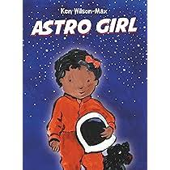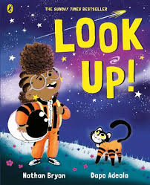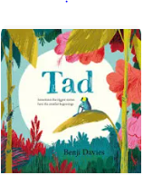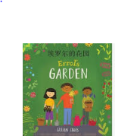
- Astro girl
- Look up!
- How to catch a star
- Whatever next
- Errol’s Garden
- Tad

PE
This term we will focus on pencil grip, and children will be encouraged to write their own name. The children will focus on drawing and cutting skills.
- Ball skills-
- Gymnastics

Mathematics
This term the children will be learning about the following subjects:
Week 1: Composition—focussing on the concept of the ‘whole’
Week 2: Composition—focussing on the composition of 5
Week 3: Cardinality and counting—counting beyond 5
Week 4: Subitising—Connect subitised quantities to numerals
Week 5: Ordinality—Order numbers to 5, focussing on each number being 1 more than the previous number
Week 6: Composition—focussing on the composition of 5 and identify missing parts
Week 7: Composition— Introduce the ‘5 and a bit’ structure using fingers and die frames as key representatives
Week 8: Comparison—focus on equal and unequal groups.
Week 9: Counting—connecting the counting sequence to ordinality.
Week 10—Comparison—use knowledge of ordinality rather that comparison by matching quantities.
Week 11: Composition—composition of 7 as 2 groups, with a focus on ‘5 and a bit’
Over the term the children will have opportunities to select, rotate and manipulate shapes in order to develop spatial reasoning skills.
Understanding of the world
- Space
- Growing and changing
Expressive arts and design
Art
- Exploring the world around us
- Studying Van Gogh
Music
The children will be learning to about pulse, rhythm and pitch, and they will explore voices and classroom instruments.
Personal, social and emotional development
-Managing self: taking on challenges
-Self-regulation: Listening and following instructions

